USER INTERFACE DESIGN
EXPERIMENT 5 : Task Analysis and User Flow Documentation of an Online Shopping Application using Lucidchart

NAME : Gayathri Boopathy REGNO:240701141

AIM:
To understand and document the steps a user takes to complete the main tasks within an online shopping application and to design corresponding user flows and wireframes using Lucidchart.

PROCEDURE:

Step1:Assigning Tasks
The following main tasks of the online shopping app were identified:

- Browsing Products

- Searching for a Specific Product

- Adding a Product to the Cart

- Checking Out

- Tracking Orders

Step2:TaskAnalysis and UserFlow Documentation

Browsing Products

Task Analysis:

  - User opens the app.

  - User lands on the Home Screen.

  - User selects a product category.

  - User views the product list.

  - User selects a product.

  - User views product details.

UserFlow:

HomeScreen → ProductCategories → ProductList → ProductDetails

Searching for a Specific Product

Task Analysis:

  - User taps the search bar.

  - User enters product name or keyword.

  - Search results are displayed.

  - User selects a product.

  - User views product details.

UserFlow:

Search→EnterQuery→SearchResults→ProductDetails

AddingaProducttotheCart

Task Analysis:

  - User browses or searches for a product.

  - User views product details.

  - User selects size ,color ,or quantity.

  - User clicks “Add to Cart”.

  - Cart is updated.

User Flow:

Product Details →Select Options →Add to Cart →Cart Updated

Checking Out

Task Analysis:

  - User opens the cart.

  - User reviews cart items.

  - User proceeds to checkout.

  - User enters shipping information.

  - User enters payment details.

  - User confirms payment.

  - Order is placed successfully.

User Flow:

OpenCart→ReviewCart→ProceedtoCheckout→EnterShippingInfo→EnterPayment Info → Confirm Payment → Place Order → Order Confirmation

Order Tracking

Task Analysis:

  - User navigates to “My Orders”.

  - User selects an order.

  - User views tracking details and delivery status.

User Flow:

My Orders →Select Order →View Tracking Details

Step3:CreatingUserFlowDiagraminLucidchart
- Created a new blank document in Lucid chart.

- Enabled Flowchart shapes.

- Used:

  - Oval for Start/End

  - Rectangle for Processes

  - Diamond for Decision points

- Connected shapes using directional arrows.

- Included decision points such as:

  - Is User Logged In?

  - Confirm Payment?

- Arranged the flow logically from login to order confirmation.

Step4:Creating Wireframes in Lucidchart
Low-fidelity wireframes were created for the following screens:

- Home Screen

- Product Category Page

- Product List Page

- Product Details Page

- Cart Page

- Checkout Page

Each wireframe included:

  - Navigation bar

  - Content layout

  - Buttons

  - Input fields

  - Product details

  - Checkout form

The wireframes visually represent how users interact with each screen.

Output:
Flowchart:

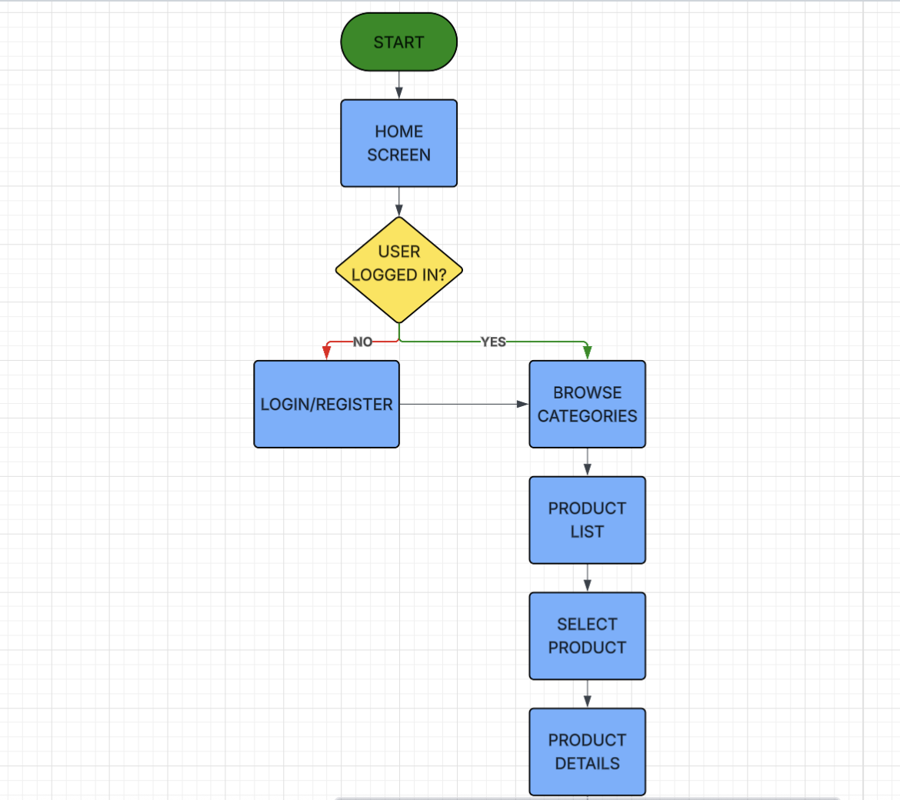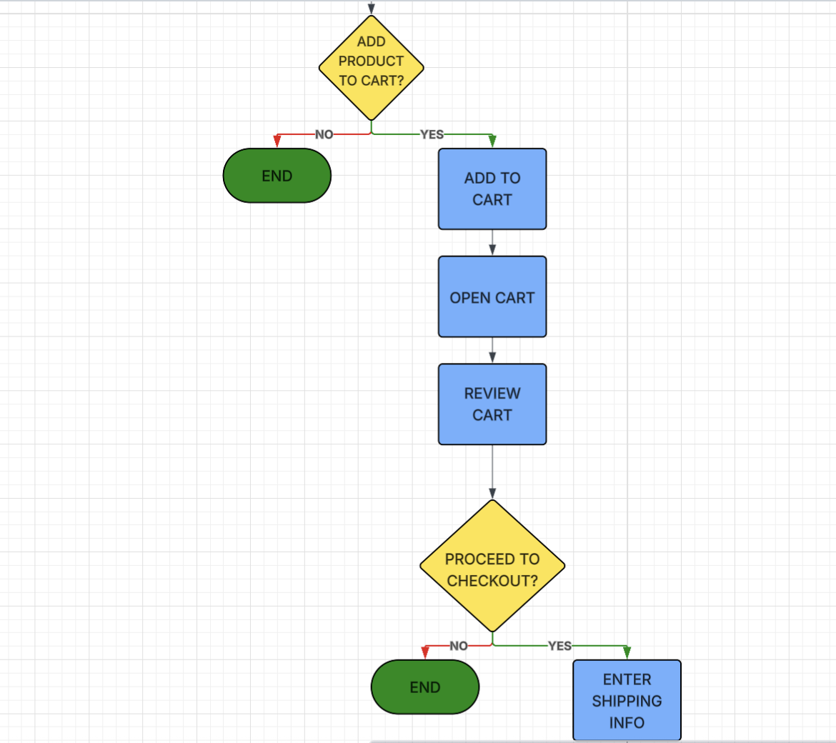
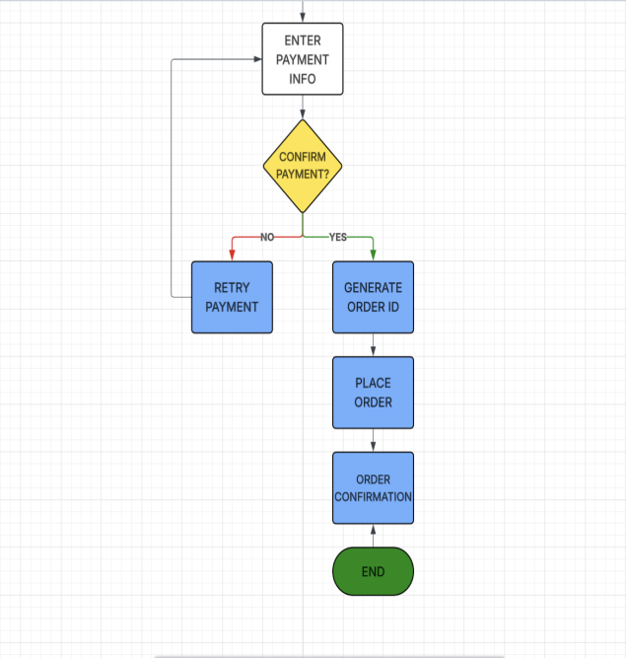

Wireframing:
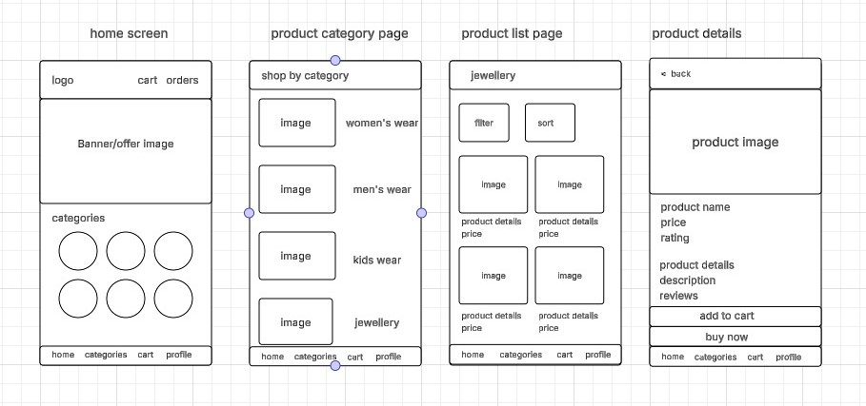

Prototype links:

https://lucid.app/lucidchart/3b72d257-3828-4825-bbc0-b6ada8d7da96/edit?viewport_loc=-21717%2C-2718%2C34697%2C16463%2C0_0&invitationId=inv_45c7a8c0-e896-424f-949c-eda5287140dd

RESULT:
The task analysis successfully identified the primary user actions within an online shopping application.Userflowsweredocumentedclearly,andcorrespondingflowchartswerecreated using Lucidchart. Wireframes were designed to visually represent the app interface and user interaction process.

